**Vault Troubleshooting**

**Vault Backup:**

Vault backup is needed, whenever any changes needs to be updated in vault service.

To take vault backup:

Login to ansible tower through saml

url : <https://tower.its.hpecorp.net/#/login>

Go to templates 🡪1. vault-backup-itg(for itg backup)🡪 click on rocket symbol.

SS. 1 (vault backup)

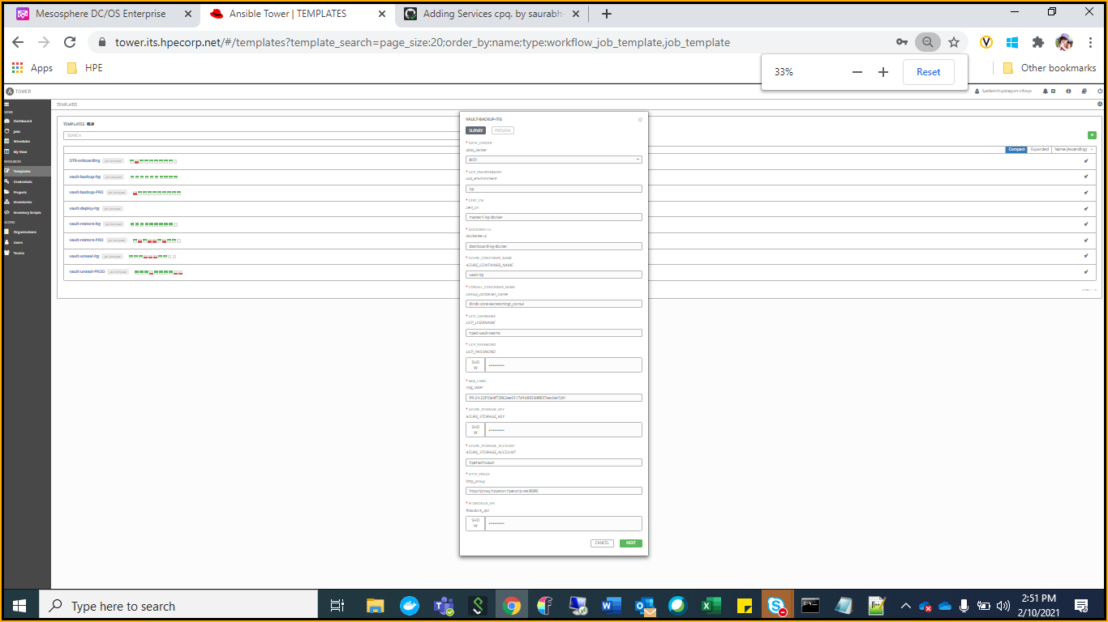

SS 2

you can see a pop-up with the details of the job in SS 2 . Click on the next button . with out making any changes to it.

Again you will see a pop-up with launch and cancel option, please hit the launch button. Then Vault-backup-itg job will start running.

Similarly run the job Vault-backup-PRO( see SS 1)

Once it is completed you can see the successful status of playbook. (See SS. 3 given below)

And you’ll get notification on **“CaaS_Platform_Health-Checks”** flow.

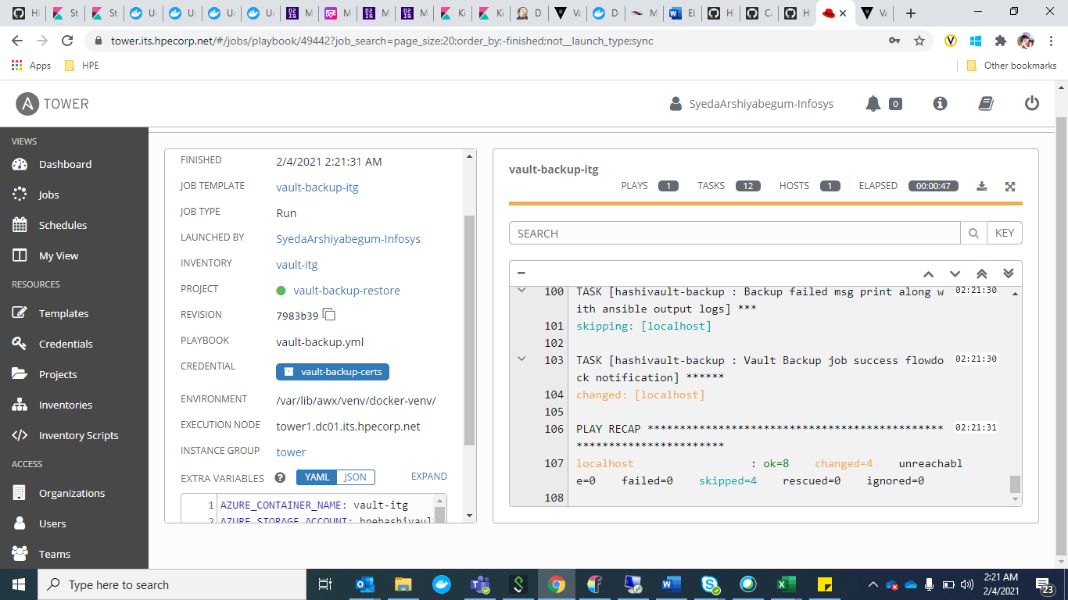

SS. 3

**Vault restore:**

When vault containers restarts or vault service restarts or consul is tampered, we have to restore database(i.e consul restore). To restore consul, run vault restore template.

Run the job “vault-restore-itg” 🡪 for restoring vault-ITG

Run the job “vault-restore-PRO” 🡪 for restoring vault-PROD.

By clicking on the rocket symbol at the right side of the job.

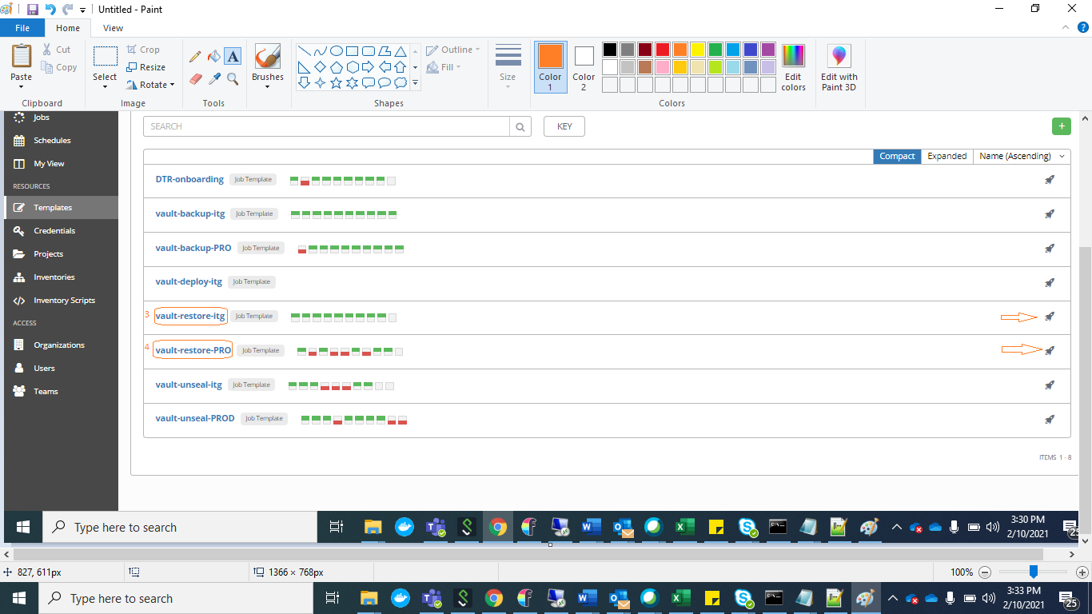

SS. 4 (Vault restore)

Once the restore is successful you can see the playbook returns ok (SS. 3)and you’ll get notification on  **“CaaS_Platform_Health-Checks”** flow.

**Vault unseal:**

Whenever the vault is sealed due to the vault service restart. Please unseal the vault by running the job under templates.

“Vault-unseal-itg“ 🡪 To unseal vault ITG

“Vault-unseal-PROD“ 🡪 To unseal vault PROD

By clicking on the rocket symbol at the right side of the job. See the SS. 5

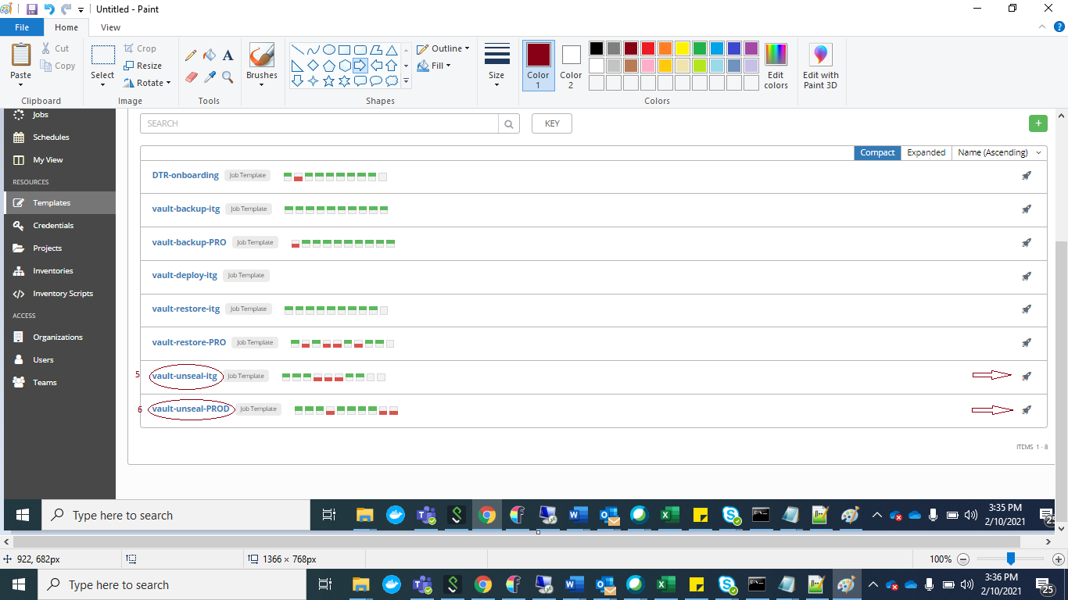

SS. 5 (vault unseal)

Once it is unsealed successfully you can see the playbook returns ok(see SS. 3) and you’ll get notification on  **“CaaS_Platform_Health-Checks”** flow.

Note: Do not make any changes in the playbook configurations.

If you see any error in the playbook, check with the team.